Example: Computing the nth Fibonacci Number
The Fibonacci numbers were introduces by Leonardo Fibonacci in 1202 as a solution to a problem about the size of a rabbit population. A famous sequence of Fibonacci numbers, 0, 1, 1, 2, 3, 5, 8, 13, 21,……
That can be defined by the simple recurrence
F(n) = F(n-1) + F(n-2) for n > 1
The two initial conditions are F(0), F(1) = 1.
Explicit formula for n^{th} fibonacci number.

Backward substitution method is not used to solve the recurrence F(n) = F(n-2) for n>1, because it fails to get an easily discernible pattern.
The theorem that describes solutions to a homogeneous second-order linear recurrence with constant coefficients is used to solve the recurrence.
The homogeneous second-order linear recurrence constant co-efficient is,
ax(n) + bx(n-1) + cx(n-2) = 0
where a,b and c are some fixed real numbers ( a != 0) called the coefficients of the recurrence and x(n) is an unknown sequence to be found.
The characteristic equation for recurrence is
ar² + br + c = 0
Let us apply this theorem to the case of the Fibonacci numbers. The recurrence relation can be rewritten as,
Its characteristic equation is,
With the roots
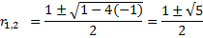
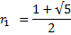
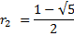
The characteristic equation has two distinct real roots.
Now, the recurrence relation is,
Substitute r₁ and r₂
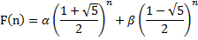
Now substitute initial conditions F(0)=0 and F(1)=1 in the above equation,
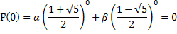
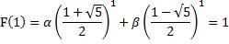
After standard algebraic simplifications we get the following system of two linear equations in two unknowns α and β:
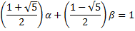
Substitute β=-α into the second equation and solve the equation obtained for α.
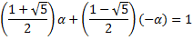
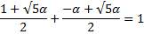
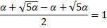
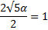
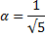
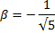
We get the values and for the unknowns. Thus,
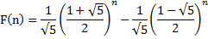
=)
Where
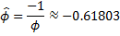
The constant is known as the Golden ratio
The value of is between -1 and 0 and hence gets infinitely small as n goes to infinity.
Therefore,
So, for every non-negative integer n,
is rounded to the nearest integer. It is hard to believe that the formula
yields all the elements of Fibonacci sequence.
Algorithm for computing Fibonacci numbers:
First method:

Algorithm F(n)
//computes the n^{th} Fibonacci number recursively by using its definition
//input: A non-negative integer n
//output: The n^{th} Fibonacci number
if n
return n
else
return F(n-1)+F(n-2)
Analysis:
The algorithm’s basic operation is addition.
Let A(n) be the number of additions performed by the algorithm is computing F(n). Then the number of additions needed to compute F(n-1) is A(n-1) and F(n-2) is A(n-2) respectively. The algorithm needs one more addition to compute the sum of A(n-1) and A(n-2).
Thus the recurrence for A(n):
The recurrence A(n)-A(n-1)-A(n-2)=1 is same as F(n)-F(n-1)-F(n-2)=1, but its right hand side is not eqal to zero. Such recurrences are called inhomogeneous recurrences.
The inhomogeneous recurrence is reduced to a homogeneous one by rewriting it as,
and substituting B(n)=A(n)+1:
B(n) is in fact, the same recurrence as F(n)except that it starts with two ones and thus runs one step ahead of F(n). So B(n)=F(n+1) and
Substitute B(n)=F(n+1). Now A(n) becomes,
We know that,
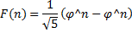
Therefore
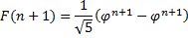
Substitute in A(n),
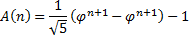
Hence, 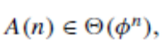and if we measure the size of n by the number of bits 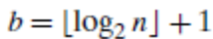in its binary representation, the efficiency class will be even worse, namely, doubly exponential: 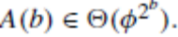

ALGORITHM Fib(n)
//Computes the nth Fibonacci number iteratively by using its definition
//Input: A nonnegative integer n
//Output: The nth Fibonacci number
F[0]←0; F[1]←1
for i ←2 to n do
F[i]←F[i − 1]+ F[i − 2]
return F[n]
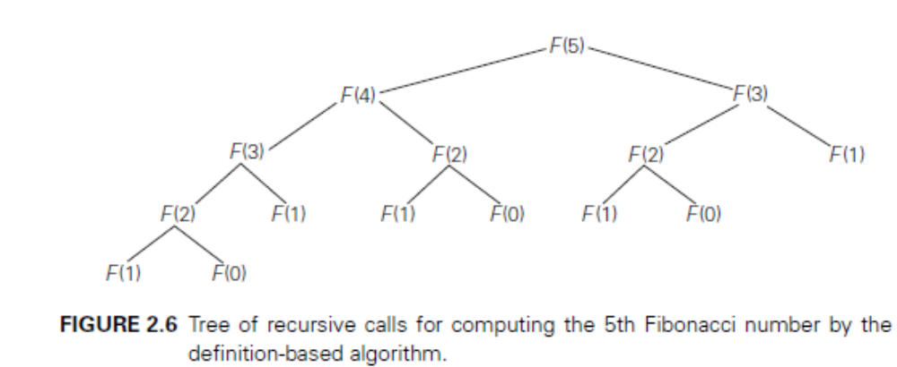
This algorithm clearly makes n − 1 additions. Hence, it is linear as a function of n and “only” exponential as a function of the number of bits b in n’s binary representation. An extra array for storing all the preceding elements of the Fibonacci sequence can be avoided, storing just two values is necessary to accomplish the task.
The third alternative for computing the n^{th} Fibonacci number lies in using formula 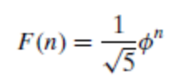. The efficiency of the algorithm will obviously be determined by the efficiency of an exponentiation algorithm used for computing 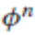. If it is done by simply multiplying φ by itself n − 1 times, the algorithm will be in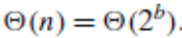.
Finally, there exists a 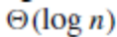 algorithm for computing the n^{th} Fibonacci number that manipulates only integers. It is based on the equality and an efficient way of computing matrix powers.
